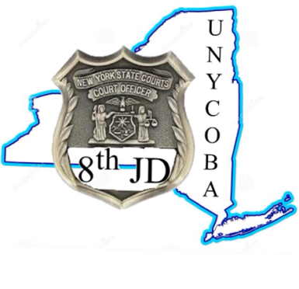Sponsorship Opportunities

**Platinum Sponsorship $1,000**

* Foursome of golf
* Company name & logo at first tee
* Company name & logo prominently displayed at all lunch & dinner tables
* Company name & logo listed in tournament program
* Four sheets of raffle tickets

**Gold Sponsorship $600**

* Company name & logo prominently displayed at registration table
* Company name & logo listed as the sponsor for one of the contests listed below:
  + Closest to the Pin
  + Longest Drive
  + Marshmallow Drive
  + Money Shot Green
* Company name & logo listed in tournament program

**Silver Sponsorship $400**

* Company name & logo on beverage cart or tent
* Company name & logo listed in tournament program

**Bronze Sponsorship $200**

* Company name & logo at one of the tees #2 -18
* Company name & logo listed in tournament program

Please fill out the sponsorship form below and return checks payable to: UNYCOBA 229 West Genesee St. P.O. Box 135 Buffalo, NY 14201

**UNYCOBA Sponsorship / Donation Form**

Business / Organization Name:

Address:

Telephone:

Contact Name:

Email:

**Sponsorship type:**

Platinum  Gold Silver  Bronze   
Please email the desired company logo to: [UNYCOBA@gmail.com](mailto:UNYCOBA@gmail.com)

**Donation Type:**

Monetary  Raffle Item  
If the raffle item needs to be picked up please contact: [UNYCOBA@gmail.com](mailto:UNYCOBA@gmail.com) -or-

Treasurer Seth Howard – 716-572-9427